MCA Academic project
TITLE: Modern motors service management system.
1.Home page
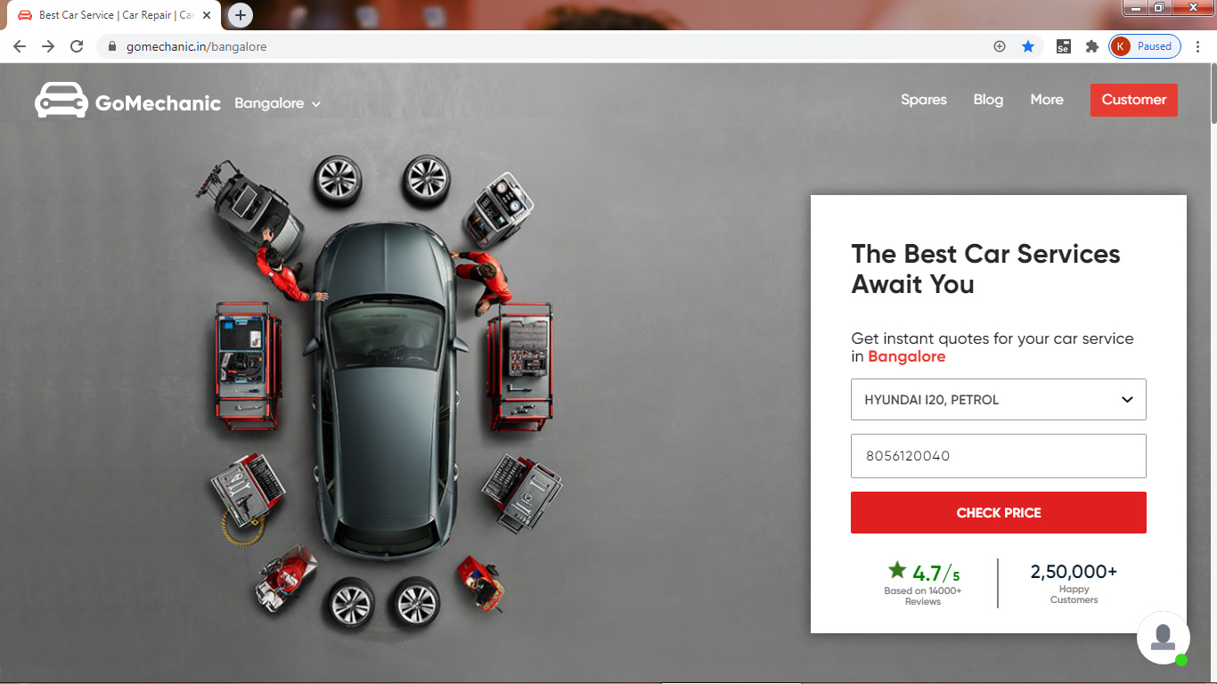
The Home page should contain these buttons:-
        - Service:-
The services should contain:-
  - Service by appointment:
  - Service at the doorstep:
These 2 should be in a service drop down listbox.

        - Spares
        - Contact us
        - Login&Signup
- Service by appointment :
The appointment details should contain these required details:
        - Name :
        - Location:
        - Phone no:
        - Date :
        - Time
Appointment has been fixed should appear in a pop-up box .
After the appointment a verification email should be sent to the registered customers.
- Service at the doorstep:
These headings should appear in a drop down list box after clicking one of the services it should lead to the respective pages.
1.Periodic services
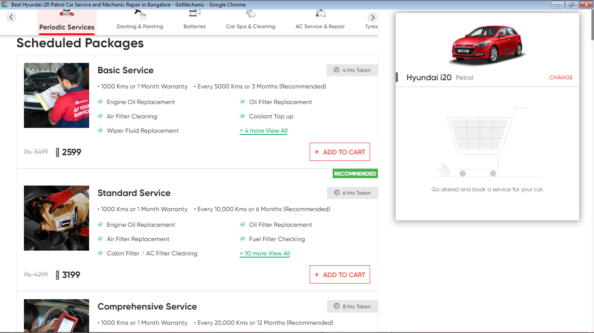
This service should contain only two packages.
2.Denting & Painting
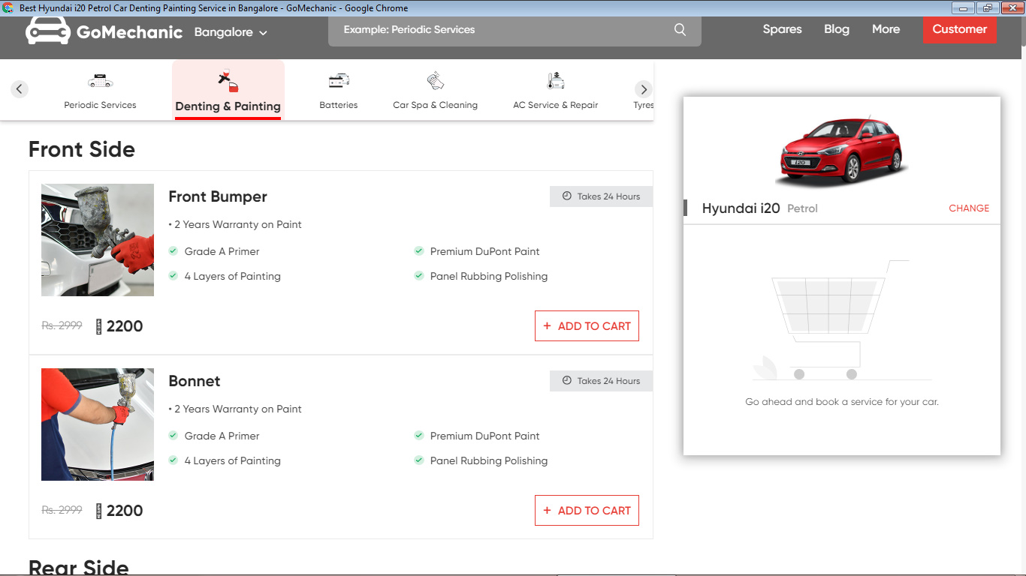
This service should contain only two packages.

3.Batteries
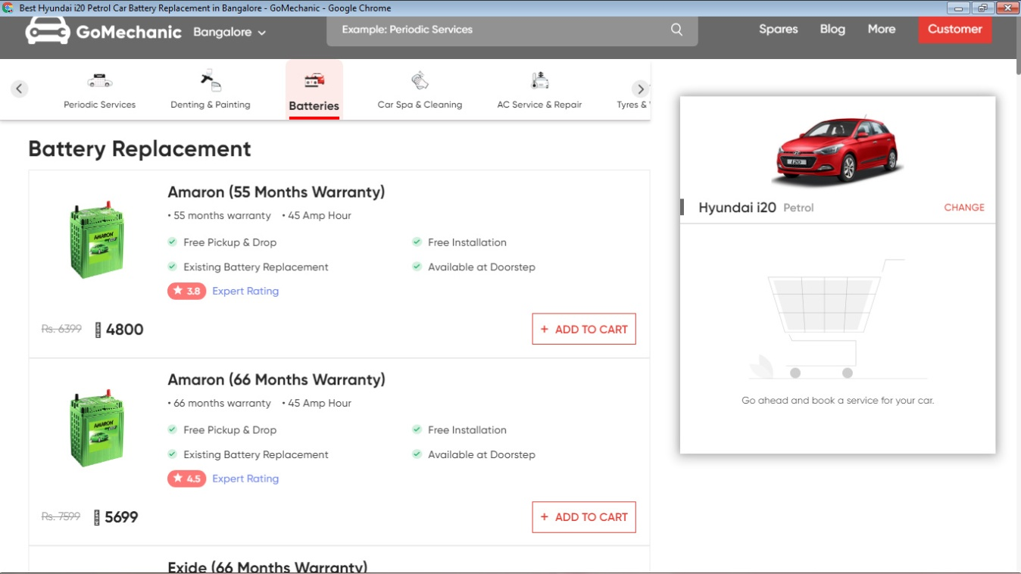
This service should contain only two packages.

4.car spa& cleaning
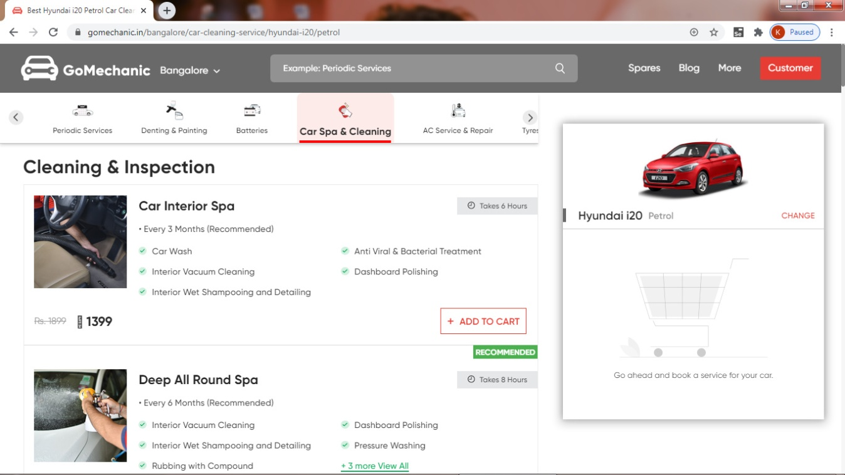

5.Detailing services
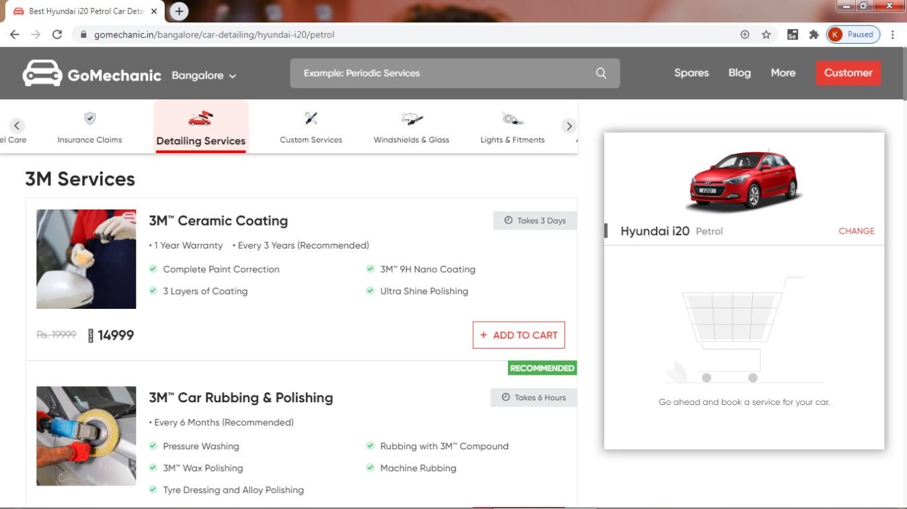
This service should contain only two packages.
6.Tyres & wheel
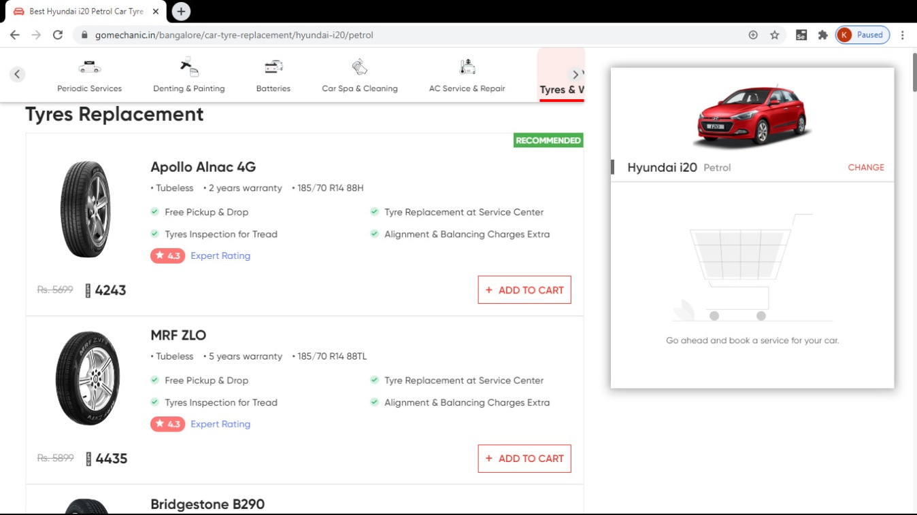
This service should contain only two packages.

- All these six modules should appear in one single page.
- After adding the required packages on the cart the customers should select their comfortable date,time and address, they are asked to pay on CASH ON DELIVERY
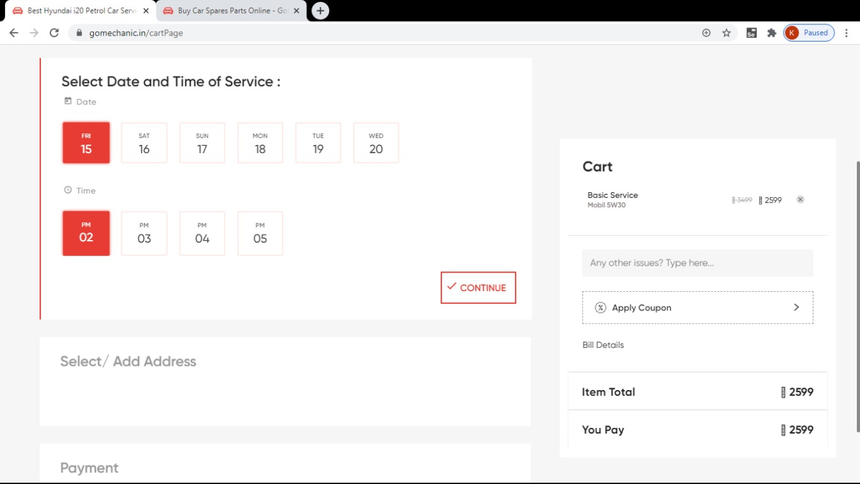

- Spares:
The spare module in homepage should contain these parts:
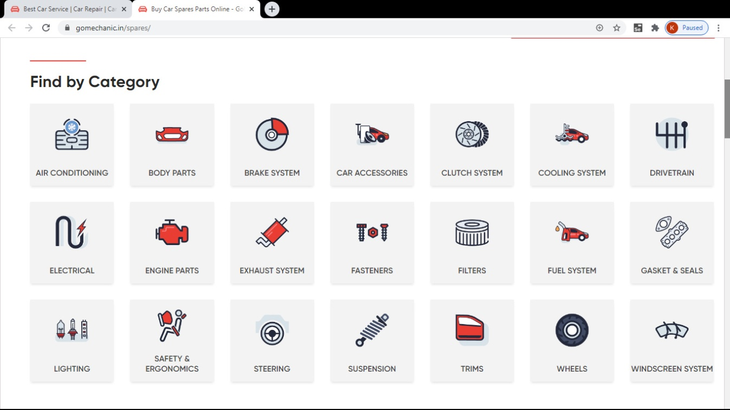
This is a sample eg:
The spare part should contain these requirements:
          - Car & Bike Accessories
          - Clutch system & engine parts
          - Steering & wheels

After clicking one of the components for eg:- car accessories it should lead to another page like buying the items after selecting one the item the item should be added to the cart after that it should proceed for payment process

- The website should contain a ADMIN PANEL .
Admin panel
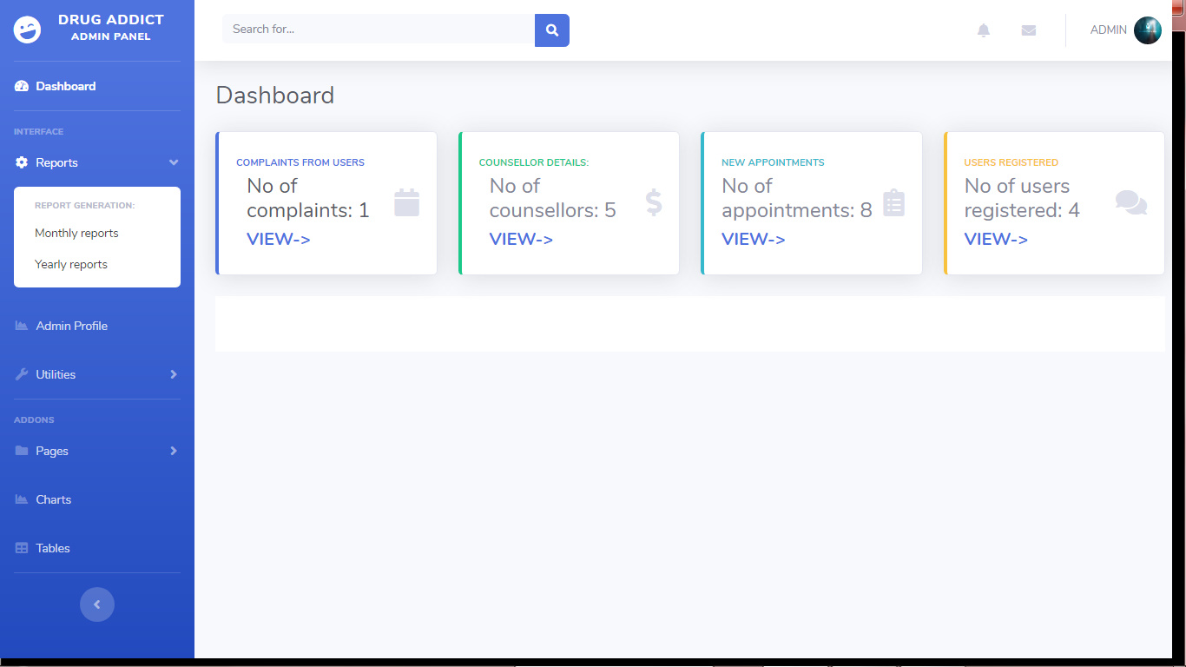
- For each items which is added to the cart it should proceed to the payment process.

